For Lease

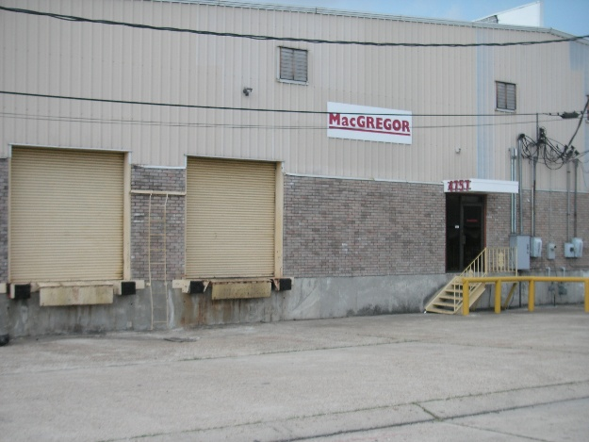

4757 River Road, New Orleans, LA 70121

Building: 5,000 Square Feet Construction: Brick, Block & Metal

Office: 832 Square Feet (17%) Eave Height: 20’

Loading: (2) 9’x10’ Dock Doors Skylights: Yes

Yard Area: No Sprinkler: Yes

Parking: Off Street Warehouse Heaters: Yes

Lease Price: $3,125.00 per mo. ($7.50 psf) NET

2025 Taxes: $3,120.56 – ($260.05 per mo.) $0.62 psf

2026-27 Insurance: $4,980.23 – ($415.02 per mo.) $1.00 psf

CAM: $425.08 – ($35.42 per mo.) $0.09 psf

TOTAL MONTHLY RENT: $3,835.49

Further Information: Randall Walker, SIOR
The Industrial Group
1504 L & A Road
Metairie, LA 70001
(504) 832-8012
Randall@igreal.com
Licensed By the Louisiana & Mississippi Real Estate Commissions
Licensed By The Louisiana State Licensing Board of Contractors.


 August 3, 2026

