For Lease

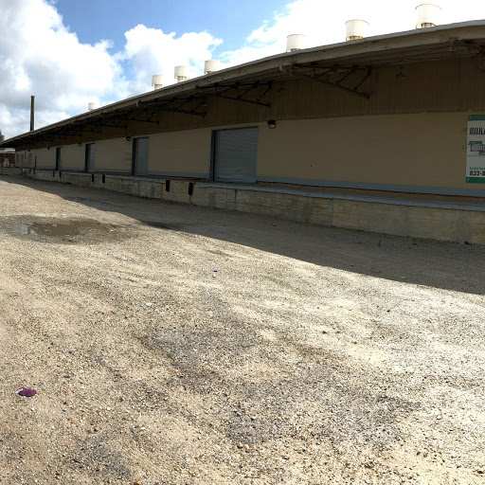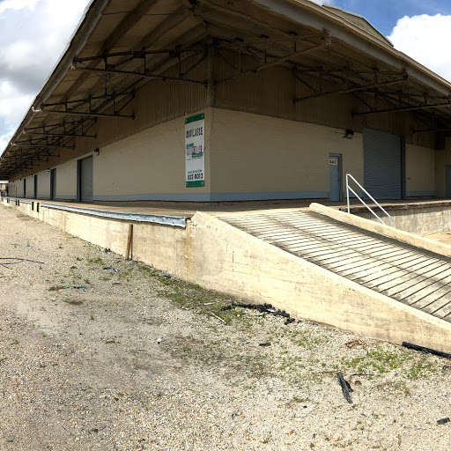

4401-05 North Roman Street, New Orleans, LA 70117

Building: 50,890 Sq Ft Skylights: Yes

Office: 628 Sq Ft Sprinkler: No

Construction: Brick & Metal Yard Area: Yes

Eave Height: 19’ Parking: Off Street

Loading: (1) 8’x9’ Dock Door, (1) 12’x11’ Dock Door, (1) 12’x12’ Dock Door, (1) 14’x12’ Dock Door, (1) 12’x10’ Dock Door, (4) 10’x10’ Dock Doors, (2) 9’x10’ Dock Doors

Approved/Active Foreign Trade Zone

Lease Price: $23,324.58 per mo. ($5.50 psf) NET
(3% annual increases in Net rental rate)

2026 Taxes: $22,524.75 – ($1,877.06 per mo.) $0.44 psf

2026-27 Insurance: $46,712.94 – ($3,892.75 per mo.) $0.92 psf

CAM: $3,571.00 – ($297.58 per mo.) $0.07 psf

TOTAL PER MO. $29,391.97

Further Information: Randall Walker, SIOR
The Industrial Group
1504 L & A Road
Metairie, LA 70001
(504) 832-8012
Randall@igreal.com
Licensed By the Louisiana & Mississippi Real Estate Commissions
Licensed By The Louisiana State Licensing Board of Contractors.



8/3/26

