For Lease

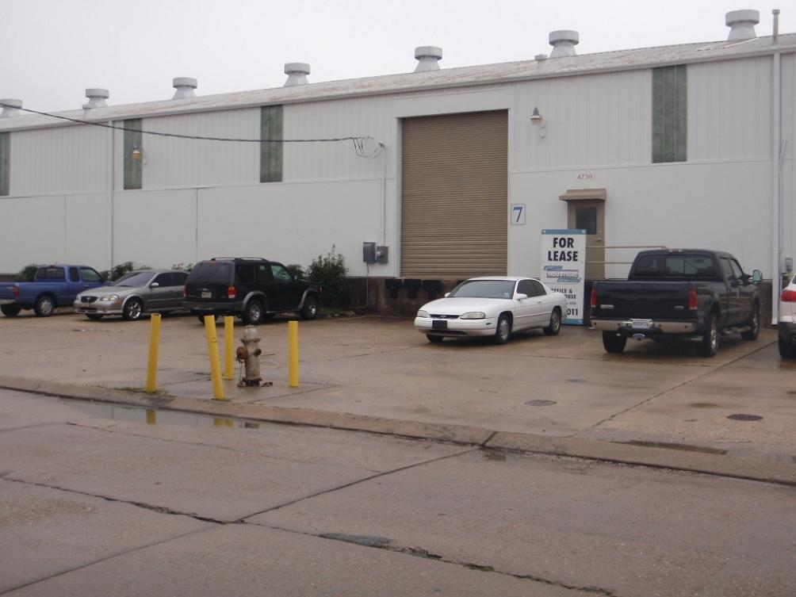

4739 River Road, New Orleans, LA 70121

Building: 10,500 Square Feet Construction: Block & Metal

Office: 580 Square Feet (6%) Skylights: Yes

Parking: Abundant Sprinkler: No

Eave Height: 20’ Warehouse Heaters: Yes

Loading: (2) 12’x12’ Dock Doors Yard Area: No

Lease Price: $4,812.50 per mo. ($5.50 psf ) Net

2025 Taxes: $7,336.46 – ($611.37 per mo.) $0.70 psf

2026-27 Insurance: $11,230.37 – ($935.76 per mo.) $1.07 psf

CAM: $534.33 – ($44.53 per mo,) $0.05 psf

TOTAL PER MONTH: $6,404.26

Further Information: Randall Walker, SIOR
The Industrial Group
1504 L & A Road
Metairie, LA 70001
(504) 832-8011
Randall@igreal.com
Licensed By the Louisiana & Mississippi Real Estate Commissions
Licensed By The Louisiana State Licensing Board of Contractors.


8/3/2026

