For Lease

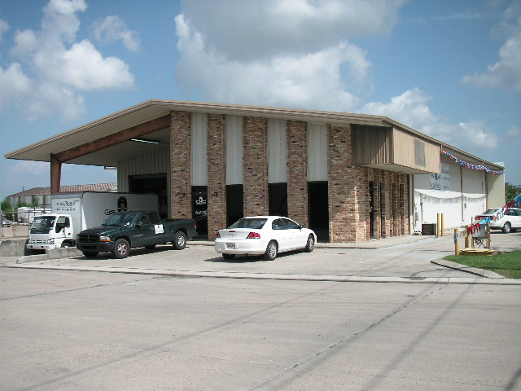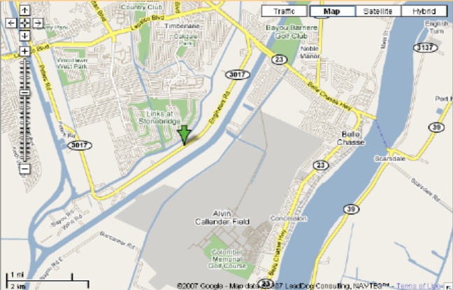

1904 Engineers Road, Belle Chasse, LA 70037

Building: 6,660 Square Feet Eave Height: 16’

Office: 1500 Square Feet Skylights: No

Construction: Brick, Block & Metal Sprinkler: No

Parking: 12 Spaces Yard Area: Yes

Loading: (1) 14’x14’ Ground Door, (1) 10’x12’ Dock Doors (truck well)

Lease Price: $3,535.35 per mo. ($6.37 psf) Net

2025 Taxes: $3,650.22 – ($304.19 per mo.) $0.55 psf

2025-26 Insurance: $11,863.58 – ($988.63 per mo.) $1.78 psf

CAM: $3,185.00 – ($265.42 per mo.) $.48 psf

TOTAL PER MO. $5,093.59

Further Information: Randall Walker, SIOR
The Industrial Group
1504 L & A Road
Metairie, LA 70001
(504) 832-8012
Randall@igreal.com
Licensed By the Louisiana & Mississippi Real Estate Commissions
Licensed By The Louisiana State Licensing Board of Contractors.




8/3/26

