For Lease

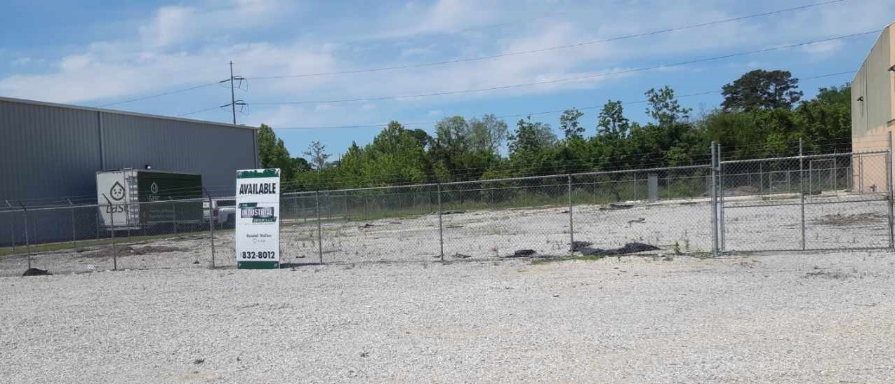

Firestone Medium Lot
(4300 Block of Firestone, Lot B-1-B)

Lease Price: $3,395.00 per mo. Net ($1.20 psf Net)

Land: 33,957.34 Square Feet Fenced and hard packed surface

Availability: Immediate Zoning: M1 Industrial District

2020 Taxes: $1,848.89 ($.05 psf)

Further Information: Randall Walker, SIOR
The Industrial Group
1504 L & A Road
Metairie, LA 70001
(504) 832-8011
Randall@igreal.com
Licensed in the State of Louisiana & Mississippi



7/31/2026

