For Lease

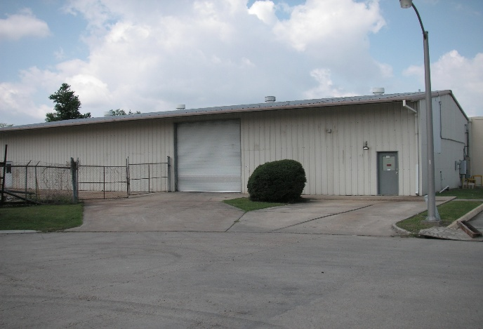

105 Lauren Drive, Belle Chasse, LA 70037

Building: 5,000 Sq Ft Loading: (2) 12’x12’ Ground Doors

Office: 600 Sq Ft 3 phase, 120-240V (600amp) electric service

Construction: Metal Eave Height: 16’

Skylights: No Sprinkler: No

Warehouse Heaters: Yes Yard Area: Yes

Lease Price: $2,083.33 per mo. ($5.00 psf) Net

2025 Taxes: $2,739.94 – ($228.33 per mo.) $0.55 psf

2026-27 Insurance: $9,654.19 – ($804.52 per mo.) $1.93 psf

CAM: $2,409.24 – ($200.77 per mo.) $0.48 psf

TOTAL PER MONTH: $3,316.95

Further Information: Randall Walker, SIOR
The Industrial Group
1504 L & A Road
Metairie, LA 70001
(504) 832-8012
Randall@igreal.com
Licensed By the Louisiana & Mississippi Real Estate Commissions
Licensed By The Louisiana State Licensing Board of Contractors.



8/3/2026

